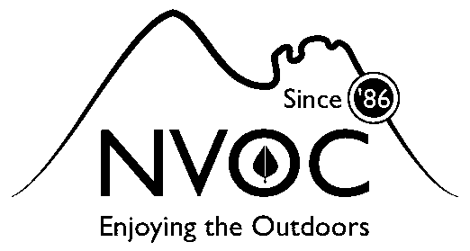
North Vancouver Outdoors Club www.northvanoutdoorsclub.ca
ANNUAL MEMBERSHIP REGISTRATION (Please print)
First Name | Last Name
Address | City
Postal Code | Home/Cell phone #
email | 2nd Phone #
MEMBERSHIP AGREEMENT:
- The North Vancouver Outdoors Club (NVOC) is a non-profit club affiliated with the Federation of Mountain Clubs of BC (FMCBC). Part of our dues go to the FMCBC for insurance & advocacy costs.
- Trips are organized and led by volunteer coordinators who have experience in the outdoors, but who may not have specific training for leading trips. Participants must realize that every trip has elements of risk and the coordinator should be consulted prior to the trip to ascertain the risk level, and that each member is responsible for his or her own safety. By signing below members agree to this.
- NVOC has a Behaviour Policy for dealing with improper, offensive or otherwise inappropriate behaviour, comments, harassment, etc. By joining NVOC, members accept terms of the policy. Copies of the Behaviour Policy are available upon request.
- Reasonable efforts are made to protect the privacy of Club members’ email addresses and other membership information. By signing below members agree to share information with club members.
- Payment for annual membership renewals are due on May 1st each year. Full year memberships are $40.00,
- New members must include a signed “Release of Liability Waiver & Indemnity Agreement” form in the full colour version; from the FMCBC. This is required for insurance coverage purposes. This “Waiver” form only needs to be signed once during your membership with the club.
- Please sign, fill in & return this form and enclose a cheque payable to: NORTH VANCOUVER OUTDOORS CLUB and mail it to the address below or pay in person to the club treasurer, with exact change or etransfer (preferred) email martina_rasmus@outlook.com with security word when sending “hiking”
IMPORTANT: By signing below, I acknowledge that I have read & understand & agree to both this Membership Agreement and the “Release of Liability Waiver & Indemnity Agreement” from the FMCBC.
Signed | Dated
1

